Full Name: Angela A. G. M. Corcino Student ID: 17485

Wells international college

**Project Management**

Assessment Two

|  |  |  |  |
| --- | --- | --- | --- |
| Name of Student | ANGELA A. G. M. CORCINO | ID | 17485 |

**Assessment 2 – Research (Online)**

Contents

Instructions: 1

Duration: 1

Multiple-choice Questions: 2

Learning Notes: 7

What is project? 7

Please put your learning notes here: 8

Project management basic 8

Project management History 8

Project management in the future 8

Document Search Index 8

## Instructions:

This is an individual assessment. Answer all the questions on the document provided by your Trainer.

## Duration:

Trainer will set the duration of the assessment.

## Multiple-choice Questions:

1. 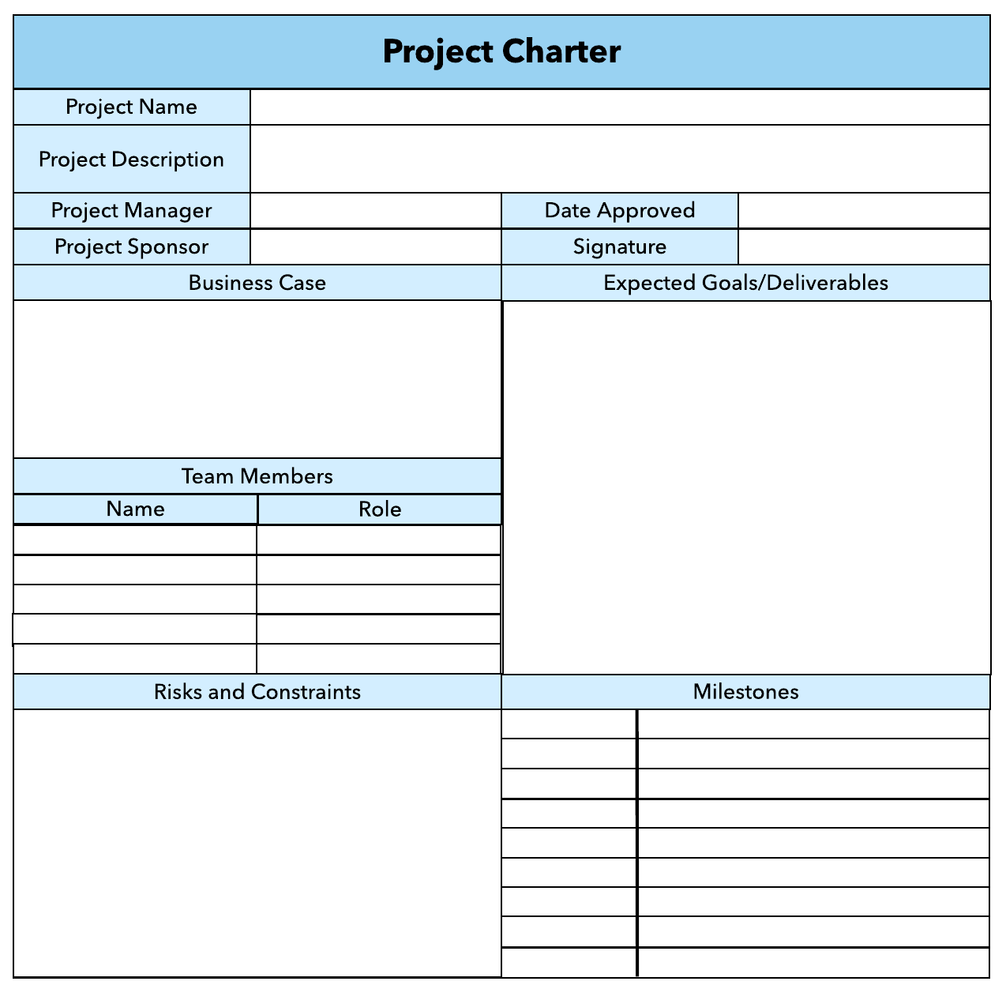What advice do we give about factoring in the commitments of project stakeholders when making your own plans?
   1. Consult student timetables to see when they might be free to attend data collection sessions.
   2. Ask external organizations what the most convenient times would be for you to visit
   3. Neither of these

d) Both A and B

Comment: your plan needs your stakeholders know before implantation.

1. Which of the following are essential components of a GANTT chart used to plan your project?
   1. Your home telephone number
   2. Your supervisor’s home telephone number
   3. The email address for the chair of the ethics committee
   4. None of the above

Comment: in order to get right or good Gantt Char, you need keep concern time, cost, scope and quality. So will get the good requirement and write good Gantt Char.

Web ref: <https://www.proofhub.com/articles/gantt-charts>

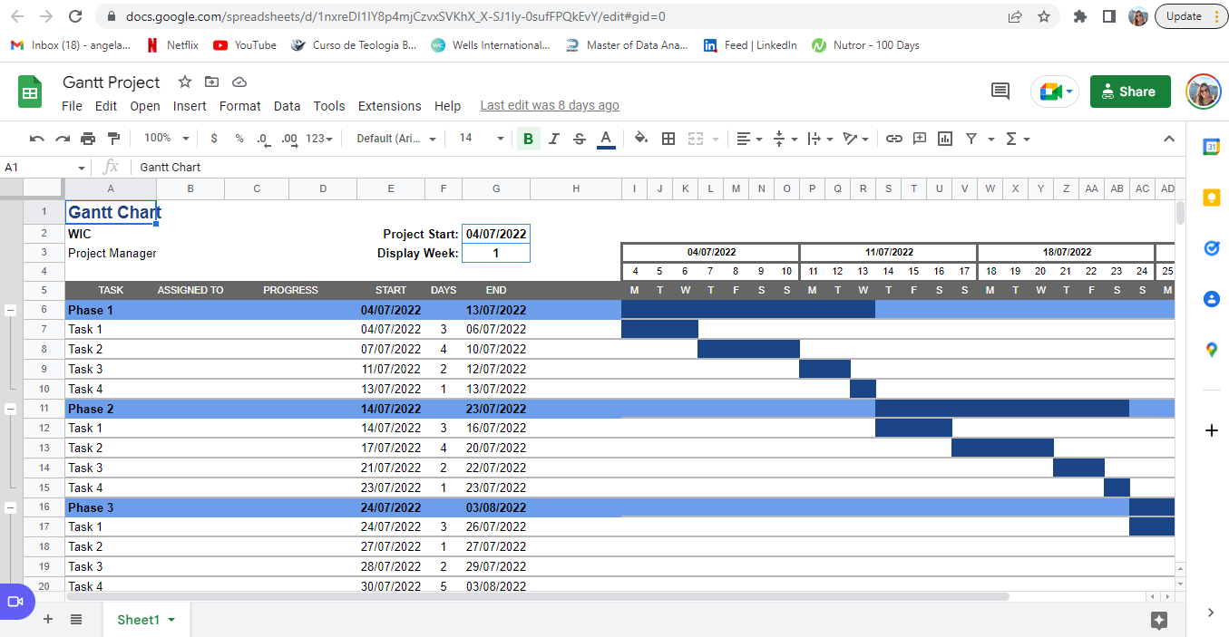

1. The intended outcome of strategy/projects integration is
   1. Clear organization focus
   2. Best use of scarce organization resources
   3. Improved communication across projects and departments
   4. Both A and C are correct
   5. A, B, and C are all correct



Comment: **Integration** management is a collection of processes required to ensure that the various elements of the **projects** are properly coordinated. It involves making trade-offs among competing objectives and alternatives to meet or exceed stakeholder needs and expectations.

Web Refer: <https://en.m.wikibooks.org/wiki/Project_Management/PMBOK/Integration_Management>

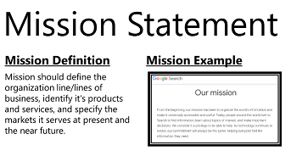

1. Which of the following questions does the organization's mission statement answer?
   1. What are our long-term strategies?
   2. What are our long-term goals and objectives?
   3. How do we operate in the existing environment?
   4. What do we want to become?
   5. All of these are answered by the mission statement

Comment: See image

Web Refer: <https://www.iedunote.com/mission>

1. Which of the following is not one of the requirements for successful implementation of strategies 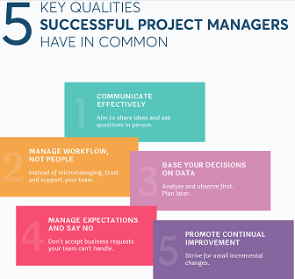through projects?
   1. Allocation of resources
   2. Prioritizing of projects
   3. Motivation of project contributors
   4. Adequate planning and control systems
   5. All of these are requirements

Comment: Successful projects are those that 1) meet business requirements, 2) are delivered and maintained on schedule, 3) are delivered and maintained within budget, and 4) deliver the expected business value and return on investment. Many factors contribute to project success, but effective project management and governance practices are particularly critical

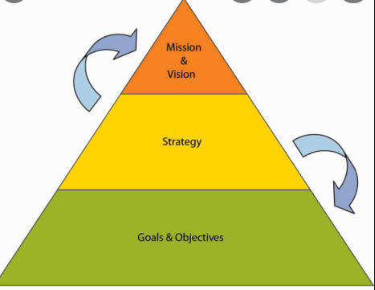Web Refer: <https://doit.maryland.gov/SDLC/Documents/What%20Makes%20a%20Successful%20Project.pdf>

1. Which of the following is the reason(s) why project managers need to understand their organization's mission and strategy?
   1. To make appropriate decisions and adjustments
   2. To be effective project advocates
   3. To be able to get their job done
   4. Both A and B are correct
   5. A, B, and C are all correct

Comment: Understanding the company strategy **helps a project manager to frame requests in ways that are more likely to gain them backing and positive feedback**. If a project manager can tie value into both their team members as well as senior stakeholders, the chances of project success are much greater

Web Refer: <https://blog.planview.com/project-managers-care-business-strategy/#:~:text=Understanding%20the%20company%20strategy%20helps,project%20success%20are%20much%20greater>.

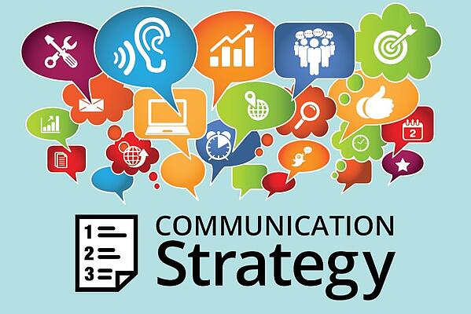

1. Which of these is the highest priority and first strategy required for any organizational change?

a) Communication

* 1. Stress management
  2. Negotiation
  3. Learning
  4. Employee involvement

Comment: Communication is the use of language to inform, to persuade, or to change someone,” the piece about audience strategy read. “Using an intelligent audience strategy is the key to successful communication, whether in job-search documents, in academic papers, or on-the-job writing and professional presentations.”

Web Refer: <https://www.alert-software.com/blog/communication-strategies>

1. 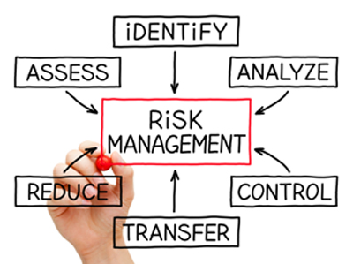Which of the following is not a procedure to obtain an understanding risk in the planning stage (described in ISA 315):
   1. Inquiries of management
   2. Analytical procedures
   3. Observation and inspection
   4. Procedures for sampling audit tests

Comment: the standard recognises that auditors will not ordinarily test all the information available to them because this would be impractical as well as uneconomical. Instead, the auditor will use sampling as an audit technique in order to form their conclusions

Web Refer: <https://www.accaglobal.com/pk/en/student/exam-support-resources/fundamentals-exams-study-resources/f8/technical-articles/audit-sampling.html>

1. Assessment of control risk includes three steps. Which of the following is not one of these steps?
   1. Obtaining an understanding of internal controls and documentation of the controls
   2. Evaluate sufficiency and appropriateness of audit evidence
   3. An initial assessment and response to assessed risk based on the design of internal controls resulting in an audit planning memorandum and audit plan
   4. A final assessment based upon test of controls of operating effectiveness

Comment: Sufficiency of audit evidence is **the measure of the quantity of audit evidence**. Appropriateness of evidence is the quality of the evidence, i.e., its relevance and reliability to support the auditor's opinion.

Web Refer: <https://www.toppr.com/guides/accounting-and-auditing/tools-of-auditing/audit-evidence/>

1. 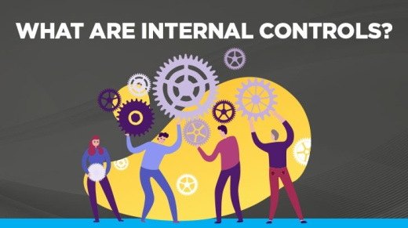Which of the following are not common internal control documentation techniques used by auditors?

a) Questionnaires

* 1. Company internal control manuals
  2. Narrative descriptions
  3. Check lists

Comment: “Internal Controls” are the mechanism that allows us to minimize risk and protect the University's resources to ensure that they are used for legitimate purposes

Web Refer: <https://audit.ecu.edu/wp-content/pv-uploads/sites/161/2018/08/Internal-Controls-Manual-Updated.pdf>

1. Overall response to assessed risk may include:
   1. Identify the absence of key controls (where controls are lacking)
   2. Identify existing controls
   3. Incorporating additional elements of unpredictability in the selection of further audit procedures to be performed
   4. Determine potential material misstatements that could result

Comment: The last thing that any project will want to face is risks. Projects are designed to take advantage of resources and opportunities and with these, come uncertainty, challenges and risk.

Web Refer: <https://www.simplilearn.com/risk-assessment-project-management-article>

1. 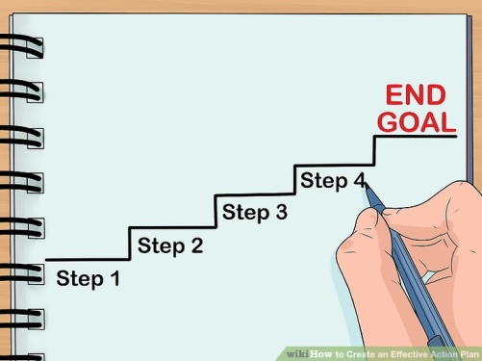Action plan Should be
   1. Specific
   2. Countable
   3. Realistic
   4. Achievable

Comment: An **action plan** is a detailed **plan** outlining actions needed to reach one or more goals. Alternatively, businessdictionary.com defines an **action plan** as a "sequence of steps that must be taken, or activities that must be performed well, for a strategy to succeed".

Web Refer: <https://en.wikipedia.org/wiki/Action_plan>

1. Which of the following is not a function of Project Management Tool?
   1. Plan a project
   2. Manage Tasks
   3. Manage Issues 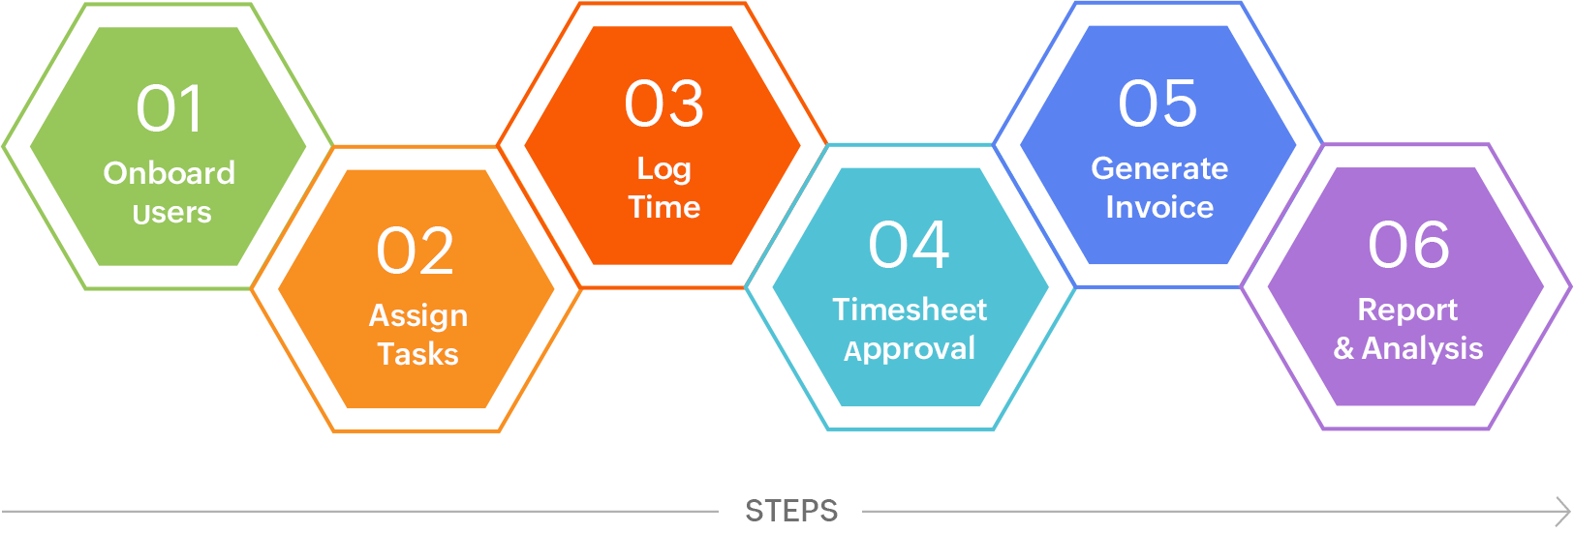
   4. Time Tracking
   5. Non of above

Comment: Project management tools are a set of software designed to help project teams to plan a project, track & manage the projects to achieve the defined project goals within the time. It also helps team members to collaborate effectively and accelerate the projects to meet the specified constraints

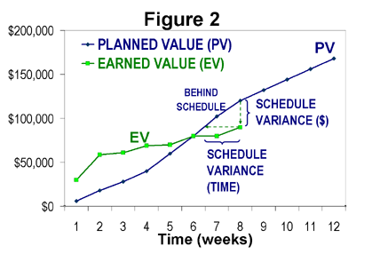Web Refer: <https://www.zoho.com/projects/project-management-tools.html#:~:text=Project%20management%20tools%20are%20a,to%20meet%20the%20specified%20constraints>.

1. John, the project manager for the ERP Project, is about to complete the project phase review. The completion of a project phase is also known as which of the following?

a) A lesson learned

* 1. A kill point
  2. Earned value management
  3. Conditional advancement

Comment: Earned value management is a project management technique for measuring project performance and progress. It has the ability to combine measurements of the project management triangle: scope, time, and costs

Web Refer: <https://en.wikipedia.org/wiki/Earned_value_management#:~:text=Earned%20value%20management%20is%20a,scope%2C%20time%2C%20and%20costs>.

1. Which of the following is not a key stakeholder in a project that creates a service internal to an 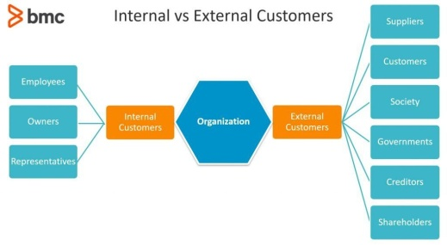organization?
   1. The project manager
   2. External customers
   3. Project vendors
   4. Project team members

Comment: To be clear, an external customer is a person who is not directly connected to your organization other than by purchasing your product or service.

Web Refer: <https://www.bmc.com/blogs/internal-vs-external-customers/>

1. Managing a project is best described as which one of the following?
   1. Establishing direction
   2. Functional controls over the project team and stakeholders
   3. Consistently producing key results expected by stakeholders
   4. Motivating and inspiring the project team to produce results that are expected by project stakeholders

Comment: A Key Result is a measurable outcome required to achieve the Objective. It contains a metric with a start and target value

Web Refer: <https://www.perdoo.com/okr-guide/#:~:text=A%20Key%20Result%20is%20a,you%20are%20to%20your%20Objective>.

1. You are the project manager for your organization. Influencing your organization requires which of the following?
   1. An understanding of the organizational budget
   2. Research and documentation of proven business cases
   3. An understanding of formal and informal organizational structures
   4. Positional power

Comment: These are not mutually exclusive choices, because a business can have a formal structure and still operate with the characteristics that define an informal structure.

Web Refer: <https://smallbusiness.chron.com/basic-types-organizational-structure-formal-informal-982.html>

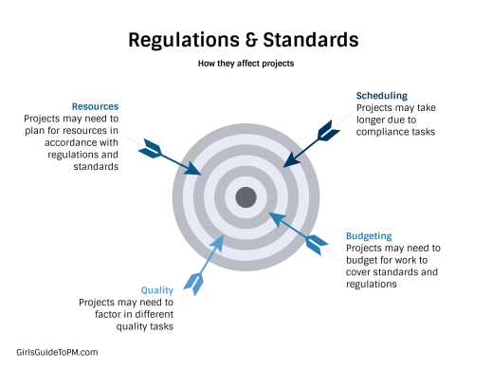

1. What is the difference between a standard and a regulation?
   1. Standards are mandatory; regulations are not.
   2. Standards are optional; regulations are not.
   3. Regulations and standards are essentially the same.
   4. Regulations are usually mandatory; standards may be seen as guidelines.

Comment: A regulation is a requirement for your project. You have to follow regulations. Regulations include applicable laws.

A standard is a guideline. Your project should follow guidelines because they are there for a reason, but if you can justify why you need to approach something in a different way, then you don’t have to follow the standard.

Web Refer: <https://www.projectmanagement.com/blog-post/52929/The-Difference-Between-Regulations-and-Standards>

1. Which of the following is an example of a deliverable at the end of the requirements-gathering phase in a software design project?
   1. Responsibility matrix creation
   2. Detail design document 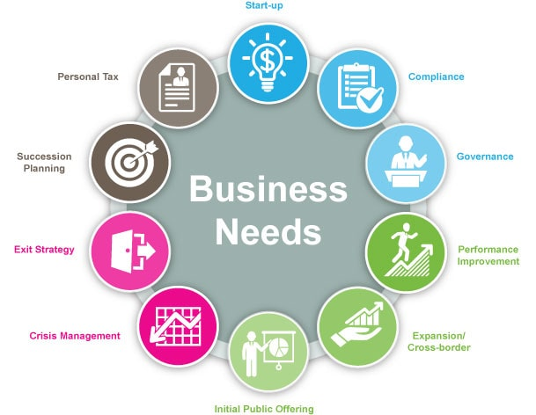
   3. Business needs
   4. Project team assembled

Comment: Business needs are what resources or methods organizations require to reach their business goals.

Web Refer: <https://www.indeed.com/career-advice/career-development/business-needs>

1. At what point in a project would a kill point be acceptable?
   1. When a project team member is not performing as planned
   2. When a project reaches the end of a project phase
   3. When a project reaches the end of its budget
   4. When a project manager determines the project team cannot continue

Comment: The kill point is the stage gate or phase review. At the review, the progress of the project is evaluated and a decision is made whether to continue or cancel the project.

Web Refer: <https://www.skillset.com/questions/what-is-a-kill-point#:~:text=The%20kill%20point%20is%20the,continue%20or%20cancel%20the%20project>.

1. Of the following, which is not an exit criterion?
   1. Customer sign-offs
   2. Quality metrics
   3. Stakeholder analysis
   4. Regulatory inspections

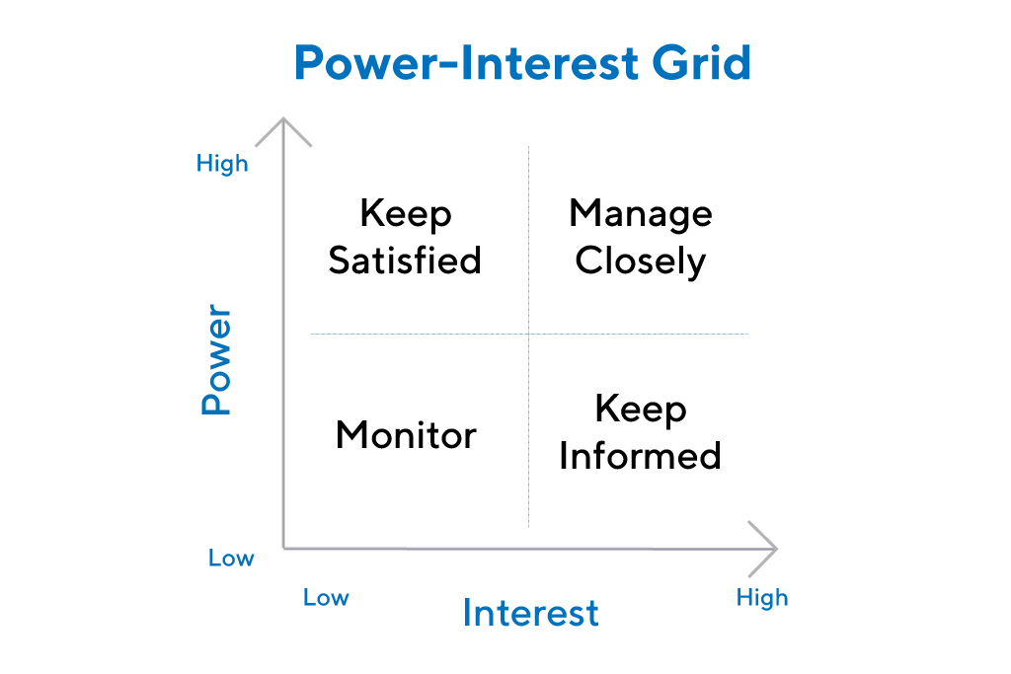 Comment: A stakeholder analysis is a process of identifying these people before the project begins; grouping them according to their levels of participation, interest, and influence in the project; and determining how best to involve and communicate each of these stakeholder groups throughout.

Web Refer: <https://www.productplan.com/glossary/stakeholder-analysis/>

1. At which point is the risk of failure the least but the consequence of failure the highest?

a) During the early stages

* 1. During the middle stages
  2. During the final stages
  3. Risk of failure is even across all project phases

Comment: These risks are things that can still negatively impact the project. Depending on the level of impact, they could ultimately lead to the failure of a project. It's important to account for and control these risks as much as possible. If it's unforeseen, it's more difficult to control for the risk directly.

Web Refer: <https://www.mentorworks.ca/blog/business-strategy/project-failure-risk-strategies/>

1. In project estimation, project manager has to provide an expert judgement, which are considered of the following EXCEPT:
   1. Impact of inflation over the project lifecycle
   2. Required labour and labour rates
   3. Material costs and assumptions
   4. Costs of quality
   5. All of above
   6. None of above

Comment: Project estimation is hard. Why? Because the only time you know precisely how long it takes to complete a project is when it’s done. Up to the point of delivery, teams use educated guesswork to predict the future. And the bigger and more complex a project is, the hazier that future is. Faulty estimates mean missing deadlines and breaking budgets—two of the main symptoms of project failure.

Web Refer: <https://www.liquidplanner.com/blog/5-methods-of-project-estimation/>

1. 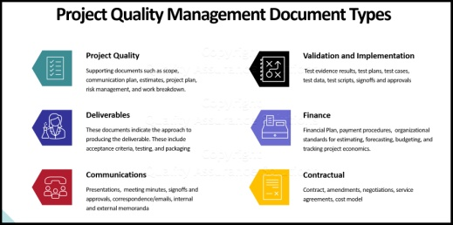Which component is/are included in Quality Management Plan
   1. Quality objectives
   2. Key project deliverables
   3. Quality standards
   4. Quality control and assurance activities
   5. All of above

Comment:

Web Refer:

1. What's an activity sequencing
   1. 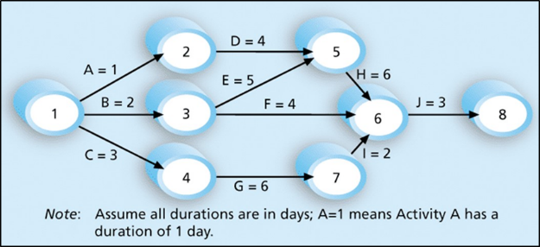The process for identifying and documenting dependencies among schedule activities
   2. The process for identifying critical activities
   3. The process for identifying ordering and schedule activities
   4. The process for planning the project

***Activity sequencing*** reviews all activities in the WBS with the goal of identifying relationships between them and classifying all the timing relationships among tasks. These relationships (aka "linkages", "dependencies", "predecessors"). Task timing relationships are important because they control task sequencing and task start and end dates. There are four types of task relationships:  
A ***finish-to-start relationship***

A ***start-to-start relationship***

A ***finish-to-finish relationship***

A***start-to-finish relationship***

Web Refer:

<https://www.e-education.psu.edu/geog871/l5_p4.html>

Comment: activity sequencing could help make your project stage very clear and easy to follow the project progress. The process for identifying and documenting dependencies among schedule activities

## Learning Notes:

<https://www.youtube.com/watch?v=rBSCvPYGnTc&t=1323s>

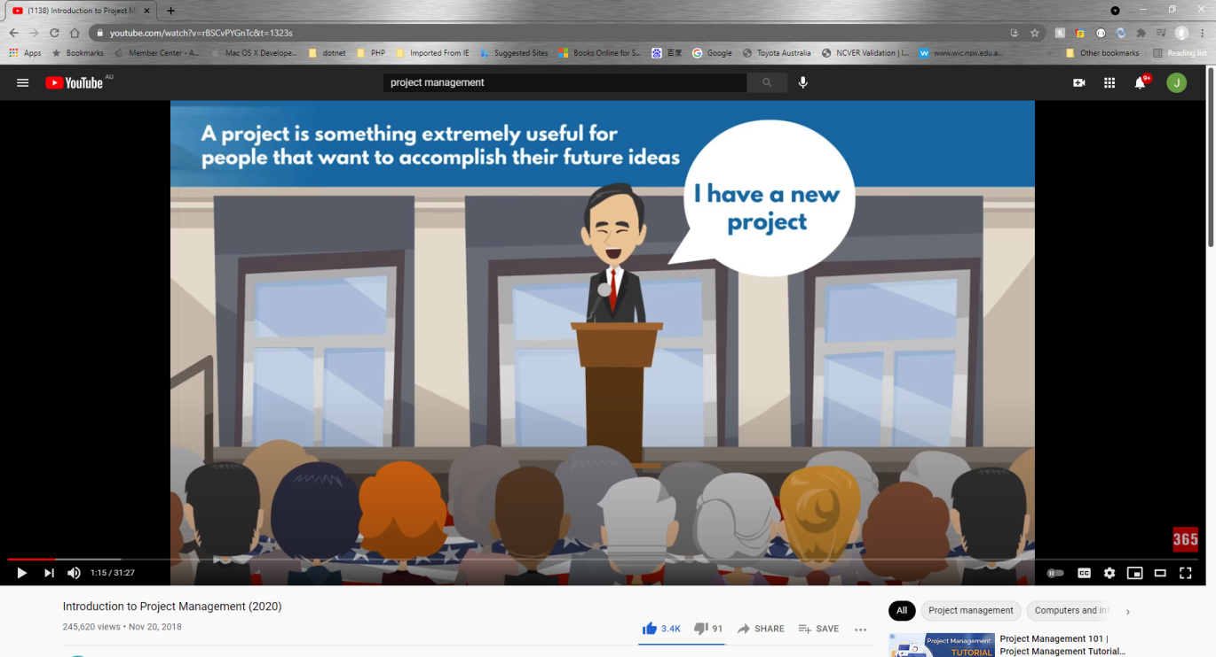

## What is project?

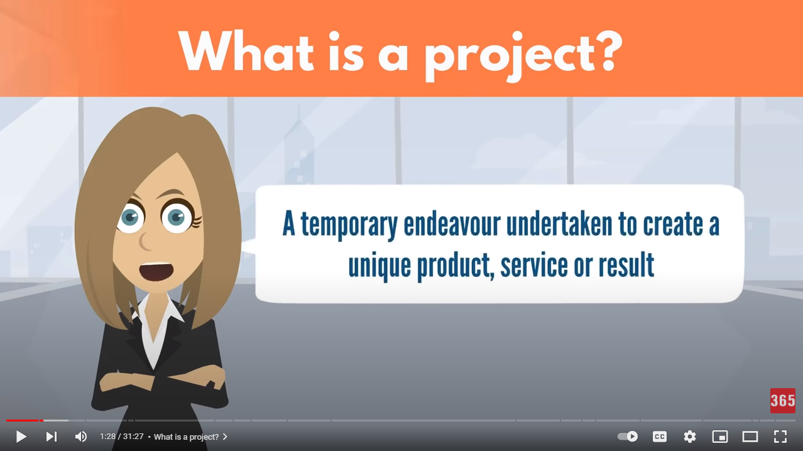

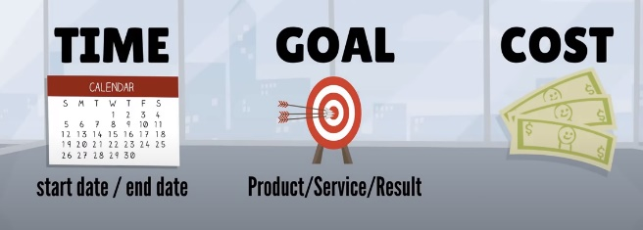project need you make a big effect in order to achieve a unique or specific goal…

project need show start date or time and finish date or time

## Please put your learning notes here:

## Project management basic

## Project management History

20 Century the Henry Gantt first make Gantt Chart Diagram. It is the revolution to know more about project management.

## Project management in the future

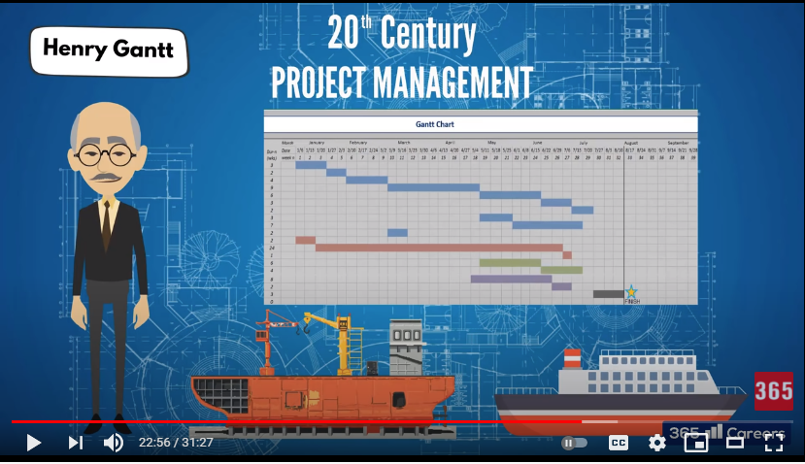

## Document Search Index

A

a GANTT chart 2

M

mission and strategy 3

mission statement 3

O

organizational change 3

P

project stakeholders 2

projects integration 2

S

successful implementation 3

U

understanding risk 4